Project Design Phase-II
Technology Stack (Architecture & Stack)

Date | 6 JULY 2026
Team ID | XXXXX
Project Name | Credit Card Auto Approval
Maximum Marks | 4 Marks

Technical Architecture:
CardApprove AI is a web-based credit card approval prediction system. The user enters applicant details in a modern web interface. The frontend sends the request through a server-side API route to a Flask backend, where a trained machine learning pipeline predicts whether the applicant is likely to be approved or rejected.

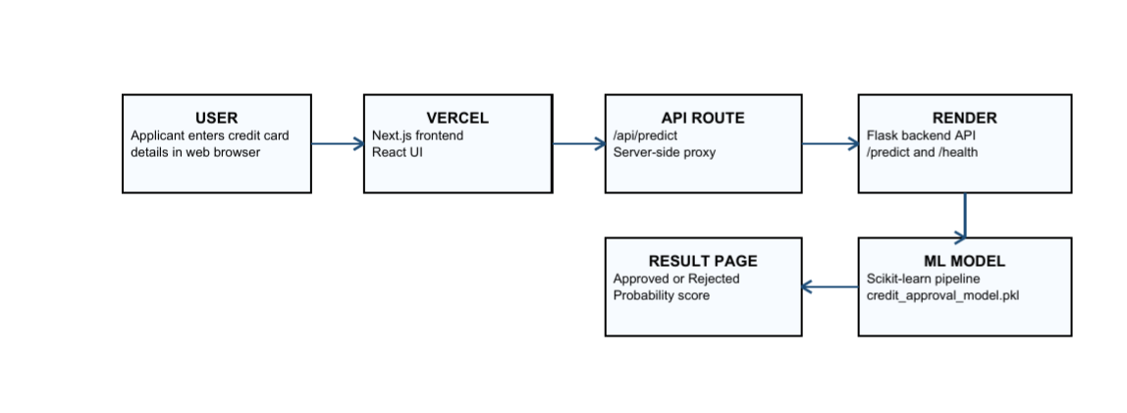
Table 1: Components and Technologies

S.NO | COMPONENT | DESCRIPTION | TECHNOLOGY
1. | User Interface | Web interface where users enter applicant details and view prediction results. | Next.js, React, TypeScript, Tailwind CSS
2. | Application Logic-1 | Handles frontend pages, navigation, form submission, and result display. | Next.js App Router
3. | Application Logic-2 | Routes prediction requests from the frontend to the backend without exposing the backend URL to the browser. | . Next.js API Route
4. | Application Logic-3 | Validates input, loads the ML model, performs prediction, and returns JSON response. | Flask, Python
5. | Database | No database is currently used in this project. | Not Applicable
6. | Cloud Database | No cloud database is currently used. | Not Applicable
7. | File Storage | Stores the trained machine learning model file | Local filesystem: server/web/models/ credit_approval_model.pkl
8. | External API-1 | Prediction API used by the frontend to communicate with the backend | Flask REST API
9. | External API-2 | No external third-party API is used. | Not Applicable
10. | Machine Learning Model | Predicts credit card approval or rejection based on applicant details. | Scikit-learn Logistic Regression Pipeline
11. | Infrastructure (Server / Cloud) | Frontend and backend are deployed separately for better maintainability | Vercel for frontend; Render for backend
Local Server Configuration
Service | URL / Configuration
Frontend | http://localhost:3000
Backend | http://127.0.0.1:8080
Frontend Environment Variable | FLASK_API_URL=http://127.0.0.1:8080
Backend Runtime | Python Flask application started using python app.py

Cloud Server Configuration
Layer | Deployment Option
Frontend Deployment | Vercel
Backend Deployment | Render cloud service for hosting the Flask backend
Model Storage | Trained model file included in backend deployment
Environment Variable | FLASK_API_URL points the frontend to the deployed backend URL

Table-2: Application Characteristics:
S.No | Characteristics | Description | Technology
1. | Open-Source Frameworks | The application uses open-source tools for frontend, backend, and machine learning.. | Next.js, React, Flask, scikit-learn, pandas, NumPy
2. | Security Implementations | Backend URL is hidden from the browser through a proxy route. Input validation is performed before prediction. | Next.js API Proxy, Flask validation
3. | Scalable Architecture | Frontend and backend are separated, so both can be deployed and scaled independently | Decoupled web architecture
4. | Availability | Frontend can be hosted on Vercel and backend can run on Render cloud service. | Vercel, Render
5. | Performance | Model is loaded once and predictions are returned through a lightweight JSON AP | Flask API, joblib, scikit-learn

